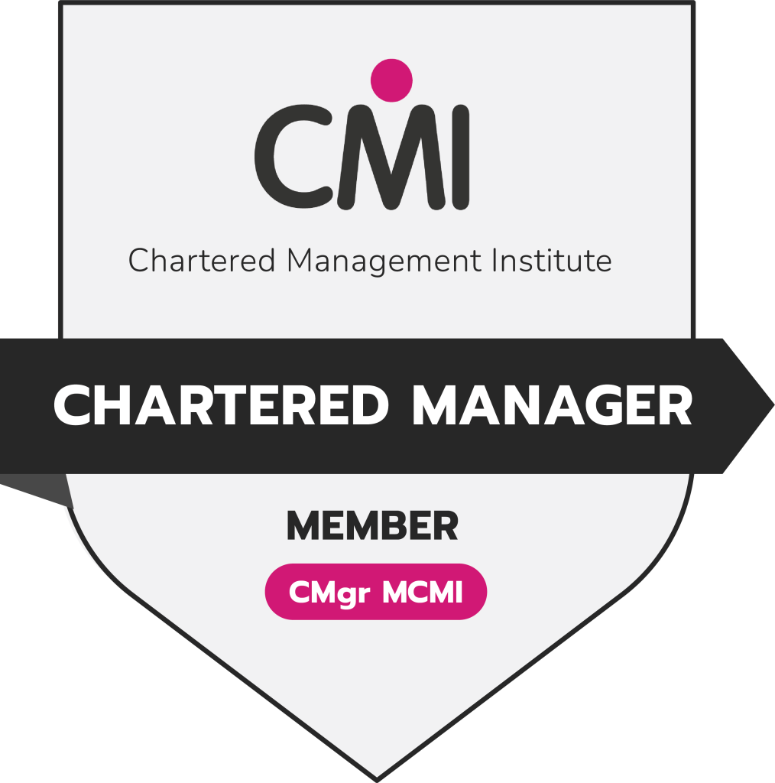

Curriculum Vitae 2026: F. K. Lwanga, Hon PhD (UK), CMgr MCMI (UK), ChMC (UK).


Contact Information:

Postal Address : P.O. Box 200464, Nakawa, Kampala, Uganda.
Website : https//www.fklwanga.me
Email : contact@fklwanga.me
Telephone : +256 700 418 052
WhatsApp : +256 750 779 977

Manager ICT,
National Building Review Board,
Plot 19, Lumumba Avenue,
P.O Box 7348 Nakasero, Kampala – Uganda.
URL: www.nbrb.go.ug, Email: fred.lwanga@nbrb.go.ug

Chartered Management Consultant|Chartered Manager| Certified AI Consultant |Digital Transformation Leader |

BRIEF RESUME:
Fred is a highly accomplished diverse professional and a high-quality & profiled ICT & Digital Transformation Leader, Corporate Governance & Policy Analyst, Management Consultant, Business Analyst, Enterprise Architect, and a strong academic & senior research scholar. He has a combination of strong leadership and advanced ICT technical skills, with twenty (20) years of working experience, fifteen (15) of which are at the policy and strategic decision-making level. He is part of the global community of technology leaders and serves as National Chair of IEEE Uganda, the apex national leadership role within the world’s largest technical professional organization. He is a Senior Member of IEEE (USA), a Certified Member of PMI (USA), a Professional Member of ACM (USA), ISACA (USA), EC-Council (USA), and CMI (UK).

He is remarkable for his excellence in management consultancy, leadership & corporate governance. He is a Chartered Manager (CMgr) the world’s highest status attainable in management, awarded by the Chartered Management Institute (CMI) in the UK. He is also a Chartered Management Consultant (ChMC), the world’s top gold-standard chartered credential in management consulting, jointly conferred by the Institute of Management Consultants and CMI (UK).

Part of an international elite cadre of highly trained ICT Directors; a Certified Security Analyst (ECSA) by EC-Council, Certified Artificial Intelligence Consultant (CAIC™) by the United States Artificial Intelligence Institute, Cisco Certified Network Associate (CCNA) by Cisco Systems, International Computer Driving License (ICDL) by the ICDL Foundation, and holds an Honorary PhD in Technology Governance & Digital Transformation, a Master of Business Administration, a Master of Science in Information Technology, a PGD in Procurement, and a Bachelor of Science in Information Technology.

He is part of a distinguished global community of technology leaders; he is currently the Manager of ICT at the National Building Review Board (www.nbrb.go.ug). Prior to that, he was the Principal Lecturer at the Uganda Institute of ICT (http://www.uict.ac.ug), Director ICT Consulting, Training, Research and Innovation and later the CIO at Hitash Consults Ltd (www.hitashconsults.com), Dean of Faculty of Science & Technology at Victoria University (www.vu.ac.ug), Consultant and later the Head of ICT at Multitech Business School (www.multitech.ac.ug); etc. His academic career as a Lecturer spans renowned universities, including Shobhit University (India), The Cyprus Institute of Marketing (UK), Uganda Martyrs University, Victoria University, UICT, UTAMU, MBS, etc. where I have advanced through academic ranks up to Principal Lecturer.

DETAILED RESUME
(a) Name, Religion, Date and Place of Birth
Lwanga Kintu Fred, Anglican, 16.04.1982, Entebbe –Uganda.

(b) Nationality, Marital Status, and Family
Ugandan, Married with 3 Children (Eloela, Ethan & Ezra)

(c) Educational Record
- Honorary PhD. Tech Governance & Digital Transformation, British National University of Queen Mary, UK
- MBA. International Business, Amity University, India
- MSc. Information Technology, Cavendish University, Uganda
- PGDip. Procurement & Logistics Mgt, Multitech Business School, Uganda

- Bachelor of Information Technology (Hons), Makerere University, Uganda

(d) International Professional Certifications (Industry-Accredited)

- Chartered Manager (CMgr) – Chartered Management Institute (UK)
The highest and most exclusive global designation in the management profession, signifying board-level leadership, strategic governance excellence, and sustained impact at the highest levels of management practice.

- Chartered Management Consultant (ChMC) – CMI & MCA (UK):
The world’s top gold-standard chartered credential in management consulting, jointly conferred by CMI and the Management Consultancies Association (MCA), signifying board-level authority in strategic advisory, enterprise transformation leadership, ethical and consulting practice.

- Certified Artificial Intelligence Consultant (CAIC™) – United States Artificial Intelligence Institute (USA)
A leading global credential in applied AI strategy, affirming advanced expertise in AI governance, ethical deployment, and strategic digital transformation at organizational and national levels.

- EC-Council Certified Security Analyst (ECSA) – EC-Council (USA).
EC-Council Certified Security Analyst (ECSA) by EC-Council, USA – Globally recognized credential for advanced cybersecurity assessment, ethical hacking, and enterprise-level security strategy.

(e) Employment Record
- Manager ICT, Uganda National Building Review Board, Mar 2023– to date
- Principal Lecturer - ICT, Uganda Institute of Information and Communication Technology Feb 2022–Mar 2023
- Director ICT Consulting, Training, Research and Innovation, Hitash Consults Ltd, Mar 2020 – Feb 2022
- Dean of Faculty of Science & Technology, Victoria University Dec 2018 – Mar 2020
- Lecturer, Victoria University Sept 2018 – Jan 2019

- Head of Business Computing and IT Department, Multitech Business School. Feb 2011 –Jul 2018
- ICT Consultant, Multitech Business School (Uganda), Oct 2010 –Feb 2011

(e) Consultancy Record

Page 1

- Consulting Senior Director (On-call) for 4IR & Digital Transformation, Hitash Consults Ltd April 2022 – to date
- Consultant, Digital Skills Framework for Basic Education, National Curriculum Development Center, March 2023
- Project Team Leader, Development of a Company Digital Business Strategy & IT Audit, KAAFO June – Sept 2022
- Consultant, Digital Transformation Curriculum Development, Uganda Institute of ICT May 2022
- Consultant, Curriculum Development MSc. Big Data Analytics, Victoria University. June 2019
- Project Team Leader, Artificial Intelligence Curriculum Development–Certificate, Victoria University. April 2019
- Project Team Leader, Digital Training Project on e-Business & Tech-Based Entrepreneurship, KAAFO June 2019
- Consultant, Curriculum Development for a MSc. Information Technology, Victoria University Oct – Nov 2019
- Consultant, ICT Professional Skills Development & Digital Innovation, Victoria University. Jul 2018 – Sept 2019
- Consultant/External Examiner, Victoria University, July 2018
- Consultant, ICT National Examination Setting, Uganda Business & Technical Exam Board, May 2018
- Consultant, ICT National Curriculum Development, UBTEB January 2018
- Project Team Leader, Training Project on Cyber Defense, UPDF’ Chieftaincy of Military Intelligence (CMI). Jan 2018–Dec 2018
- Project Team Leader, Curriculum Development for Master of Business Admin, Multitech Business Sch Sept 2017 – June 2018
- Project Team Leader, Digital Literacy Training Project to Wakiso District Local Government County Chiefs, March – Sept 2016:
- Project Team Leader, Curriculum Development –19 undergraduate Programmes, Multitech Business Sch. Feb 2016–April 2017:
- Project Team Leader, Curriculum Development - 12 Academic Degrees & Diplomas, Stawa University Sept 2017 – June 2018
- Project Team Leader, Developing and Implementing an e-Learning System, Multitech Business School. Sept 2013 – Jan 2014
(f) International Professional Body Membership
- Chartered Management Institute (CMI), United Kingdom 2024 – to date
- The Institute of Electrical and Electronics Engineers (IEEE), United States. 2022 – to date
- Association for Computing Machinery (ACM), United States. 2025 – to date
- Project Management Institute (PMI), United States. 2025 – to date
- Information Systems Audit and Control Association (ISACA), United States 2021 – to date
- ICT Association of Uganda, UG. 2025 – to date

(g). Professional Board Membership & Societal Engagements
- National Chair, IEEE Uganda Dec 2025 to date
- Chairperson, Board Member, ICT Technocrats Ltd. 2018 – to – date
- Founder Chairperson and Advisor, UICT IEEB Student Branch, Kampala Uganda 2022 – to date
- Member of Senate, Victoria University. 2018 – 2020
- Member of the Management Team, Victoria University. 2018 – 2020

- Chairperson Faculty Board of Science & Technology, Victoria University. 2018 – 2020

- Member, ICT Directors Forum, Research and Education Network for Uganda (RENU) 2011 - 2014
- Chairperson ICT Departmental Board, Multitech Business School (Uganda). 2011– 2014
- Chairman, Curriculum Development Committee Multitech Business School. 2011– 2014
- Chairman, Heads of Departments Forum, Multitech Business School. 2011– 2014
- Member, Academic Board, Multitech Business School (Uganda) 2011– 2014
- Member, Editorial Board for Research & Publications Multitech Business School. 2011– 2014
- Member, Management Board, Multitech Business School (Uganda) 2011– 2014
- Member, ICT Directors’ Forum, Research & Education Network for Uganda. 2011– 2014
- President, Multitech ICT Club, Multitech Business School (Uganda) 2011– 2014
(h). Referees
Page 7

- Mr. Herbert Zziwa, Manager Communications, National Building Review Board, Tel: +256 783910520, Email: zziherbert@gmail.com.

- Mr. Kasozi Robert, Technical Director, Hitash Consults Ltd, Tel: +256 702363435, Email: kasozirobert1@gmail.com / kasozi@hitashconsults.com

- CPA. Lutalo Richard, Accountant, Multitech Business School, Tel: +256 701 1020, Email: Lutalo.richard@yahoo.com.

|Certified Artificial Intelligence Engineer | Certified IoT Engineer | Certified Cybersecurity Engineer | Certified Cloud Security Engineer | Certified Data Privacy Solutions Engineer| Certified Big Data Engineer | Professional Machine Learning Engineer |

Page 3

Page 3


Page 2

